Atomorbitale
K | 1s0 | 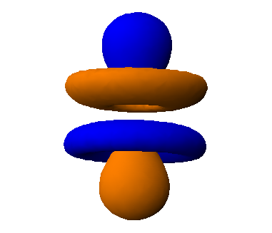
L | 2s0 | 2p-1 | 2p0 | 2p+1
M | 3s0 | 3p-1 | 3p0 | 3p+1
 |  | 3d-2 | 3d-1 | 3d0 | 3d+1 | 3d+2
N | 4s0 | 4p-1 | 4p0 | 4p+1
 |  | 4d-2 | 4d-1 | 4d0 | 4d+1 | 4d+2
 |  |  | 4f-3 | 4f-2 | 4f-1 | 4f0  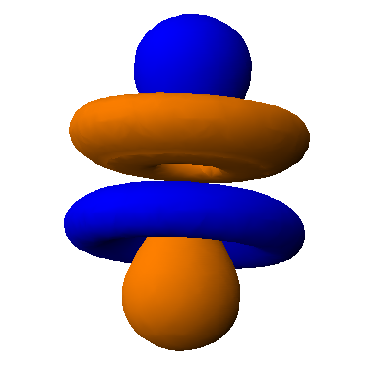
 |  |  | 4f+1 | 4f+2 | 4f+3

